Process Book

* **Overview and Motivation:** Provide an overview of the project goals and the motivation for it. Consider that this will be read by people who did not see your project proposal.

We chose to look into the relationship between NFL Draft Position and NFL Success because it is not always clearly communicated in sports. Each of us being a fan of an NFL team (with limited success on Joe and Rebecca’s side), we want to see what number picks might help our teams the most. We are also interested in looking at the distribution of different positions throughout different rounds of the NFL Draft. It is always thought that quarterbacks are most frequently selected in the first round, but this may simply be a common misconception. Additionally, we want to see if players like Tom Brady, who was a 6th round pick, are as anomalous as they appear to be.

Our overall goal is to provide an interactive tool where you can determine different drafting facts and trends and make informed decisions about the best places to draft certain positions.

* **Related Work:** Anything that inspired you, such as a paper, a web site, visualizations we discussed in class, etc.
  + We were inspired by the dataset to provide a comprehensive view of the influence of a draft pick number over a player’s success, as well as the many interactive tools we discussed in class like the principles of Focus + Context, brushing, and aggregation.
* **Questions:** What questions are you trying to answer? How did these questions evolve over the course of the project? What new questions did you consider in the course of your analysis?
  + The main question we are asking is how NFL draft pick number relates to NFL success over a career. As we initially viewed the data, we noticed that, with such a large data set, there were many questions that we could answer relating to NFL data. Some secondary questions we asked were:
    - What teams acquired players from certain positions who proved to be, perhaps, more successful than predicted (by pick number)?
    - For what years were teams good at picking certain positions?
    - Is it as rare as we think it is for worse picks to perform well in the NFL?
* **Data:** Source, scraping method, cleanup, etc.

We found our main dataset on kaggle: <https://www.kaggle.com/ronaldjgrafjr/nfl-draft-outcomes>. We shortened the data to include only years 1995 to 2015, and

**Data Processing:**

We had our data cleaned by the first update so that we were able to show a visualization. The dataset is very well organized already, but there are many unused features in the dataset that we filtered out. The key attributes we kept are PlayerID, DraftPick, DraftYear, Position (filtered into six simple groups), CarAv (career value), First4AV (first four years of playing value), NFL Draft Team, and an array of career statistics varying based on position. This array is used in statistics sidebar when clicking on a data point. Although this feature is optional, the data will still be filtered this way in case this feature makes it into production.

After reading the data into JavaScript, we plan on using d3.nest() to nest the data by year. Although this will not be used to create multiple scatter plots, it will make aggregating CarAV and First4AV by year and querying our dataset by year easier when brushing and making bar graphs (if implemented). We also plan on removing years from the dataset based on the raw number of points. If our visualization is processing too much information dynamically, rendering could become an issue and thus slowing down our interactions.

* **Implementation:** Describe the intent and functionality of the visualizations you implemented. Provide clear and well-referenced images showing the key design and interaction elements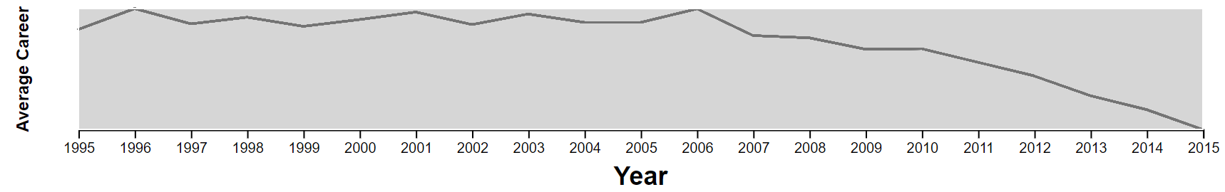
  + We implemented a year-based selection in which you can drag the endpoints of the rectangle to select a range of years and drag the rectangle itself to change the years within the range. This is so that we are able to choose based on more recent/older data. By updating the rectangle, the main scatterplot and additional plot is automatically updated. The plot shown in the year focus plot is a line plot that shows the average career statistic (Career Average or First Four Years).



* + Our main plot is a scatterplot. Each point represents a player. The colors are coordinated based off of the player’s positions: for example, blue represents a quarterback. The x-axis represents the increasing pick number of the players: meaning that the higher the pick (the “better” player in college football), the lower the x value. The y-axis represents the career approximate value, which is a standardized statistic based off of many career statistics. The higher a value, the better the player has performed in the NFL.

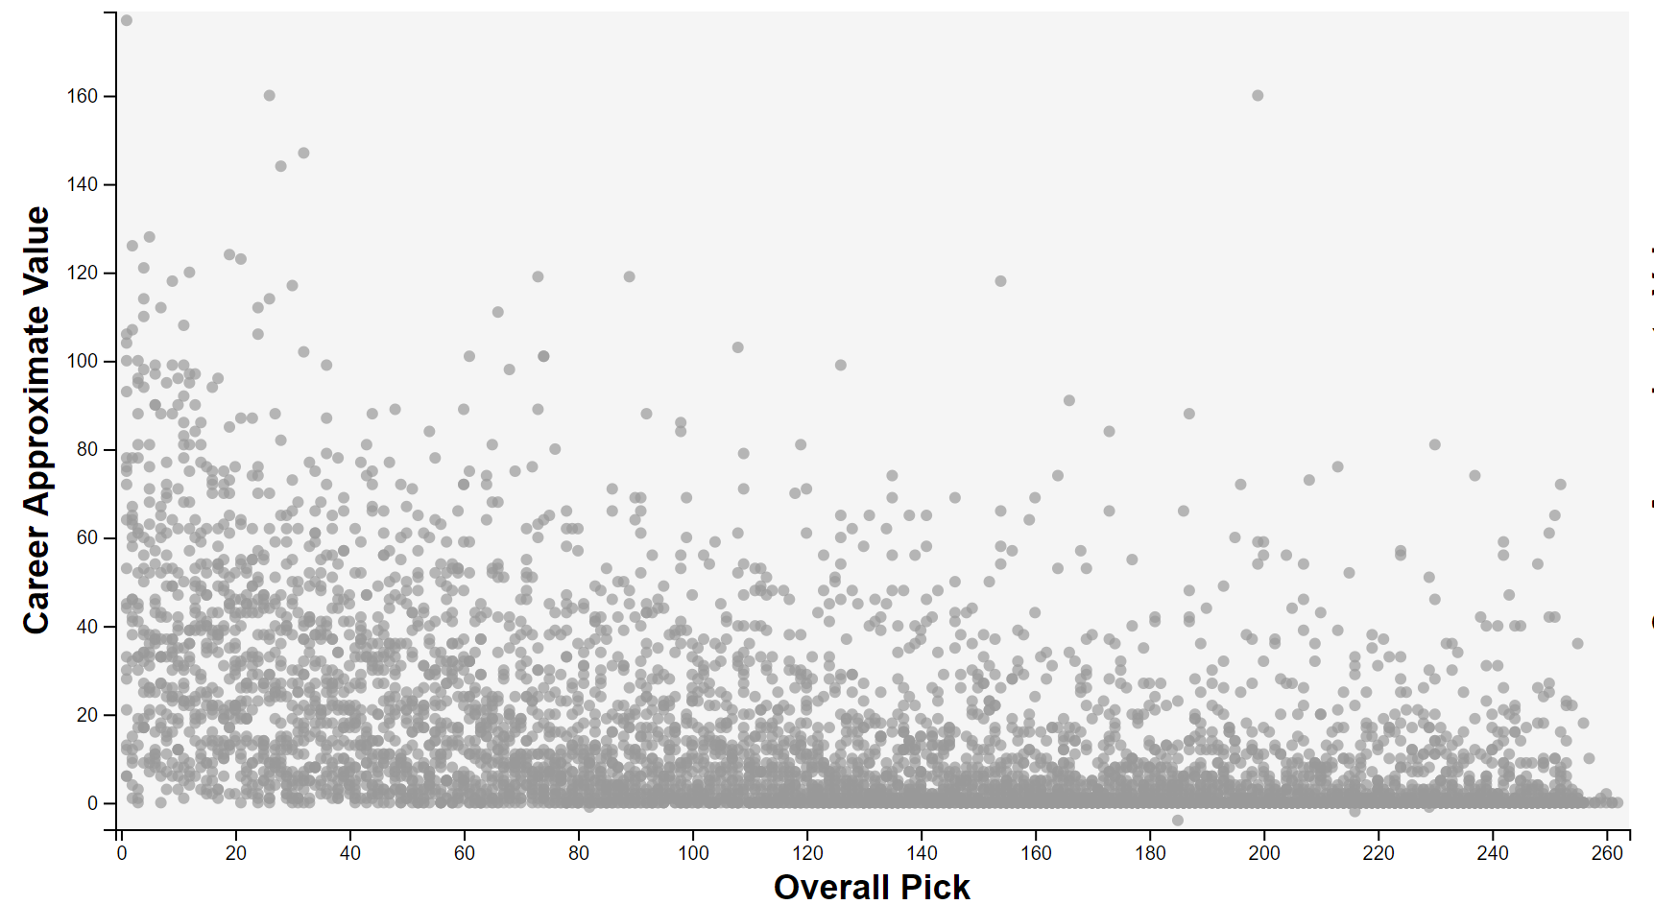

* + An update we made to this main plot is that the background color was lightened, and the opacity of the points was increased in order to increase contrast. The default plot with All points selected also has no colors corresponding to position, in order to cut down on business.

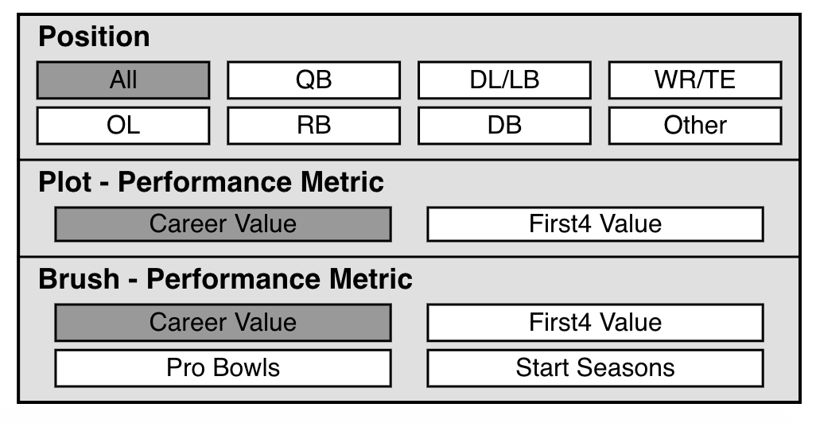

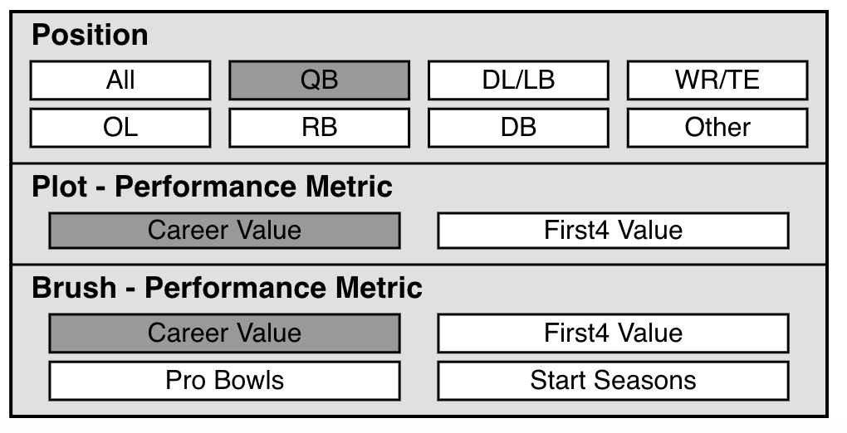

* + Our options box is one of our main interactive elements. You can click on any position and performance metric to choose what to look at in the main scatterplot.

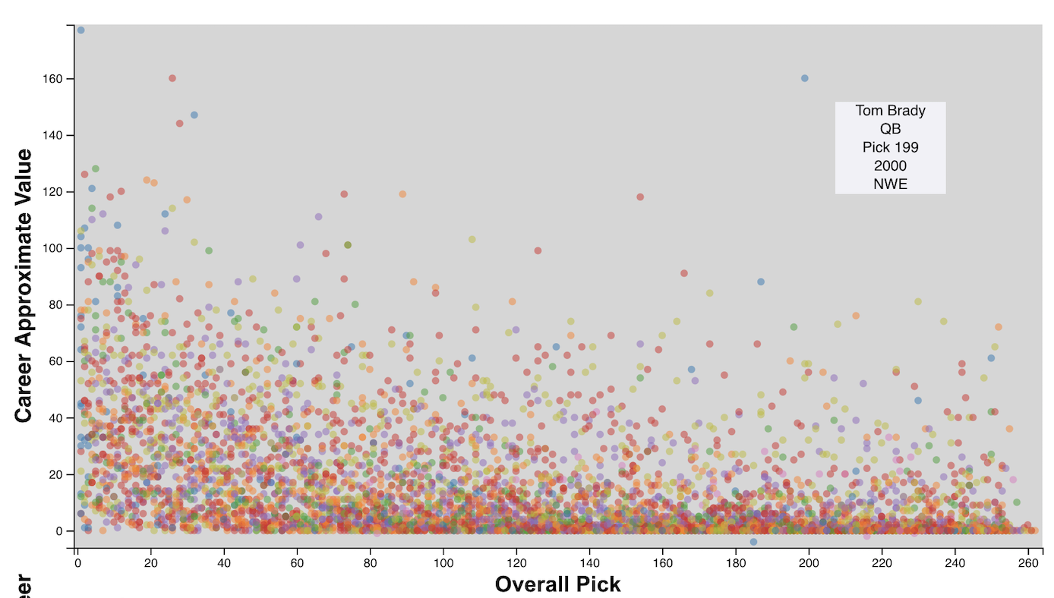

* + We are able to hover over a point to show the name, position, pick number, year, and team of that player. This is helpful to indicate what people may be outliers.
  + This portion of the visualization helps to filter the data by the round players were drafted in. It is key since it de-clutters the data and allows more precise observations.
* **Exploratory Data Analysis:** What visualizations did you use to initially look at your data? What insights did you gain? How did these insights inform your design?
  + Initially, we made a single scatterplot relating Pick to Career Average. The plot was quite overwhelming and did not show a clear correlation between lower draft pick and higher career average. From this, we knew it would be important to show the data in separate views to see if there is a more realizable relationship between pick number and NFL success. We decided that we should be able to filter the scatterplot showing pick vs success via a variety of methods – the ones we chose are by round, position, and year range. Additionally, our second view was decided to be a team aggregated stat for the data points view on the scatterplot.
* **Design Evolution:** What were the different visualizations you considered? Justify the design decisions you made using the perceptual and design principles you learned in the course. Did you deviate from your proposal?
  + When we were looking at how to transition data when we were changing positions, at first, the interaction had all old points rising toward the top left point while fading out, whereas the new points were falling from the top left point while fading in. After discussion, we decided that it would be a less confusing transition to just have old points fade out and new points fade in.
  + We decided to use a double-headed slider for selecting by year. This tactic is useful for selecting a range of discrete entities. The year slider shows a line plot of the average selected career statistic (Career Average or First Four Year), rather than the original simple point plot. The line shows more of the trend which would let the user know what range of years might be of interest.
  + We chose to have a second view that would be able to be modified by brushing that would show how a performance metric relates to a different NFL team for the set of points located within the brush. This is useful for providing some more context behind the data instead of just having our main view with all the different players. This way, the user is presented with both the pick vs career average and the ‘usefulness’ of the players to teams within the selected time period/round/position.
  + We decided to add another selection mechanism to choose the round (1 – 7) of picks. This allows the viewers to have an even more in-depth view of the data.
* **Analysis:** What did you learn about the data by using your visualizations? How did you answer your questions? How well does your visualization work, and how could you further improve it?